JIRA integration to CMP

**Capturing CMP Applications as ( User Story ) and milestones as (sub tasks):**

Here we are mapping User Stories in Jira as CMP applications, each application represents a single user story. Each field in User Story has a mapping to dedicated columns on CMP application.

The Sub-Tasks of these user story is represented as Milestones on CMP. The sub-tasks fields are mapped to dedicated columns of Milestones on CMP.

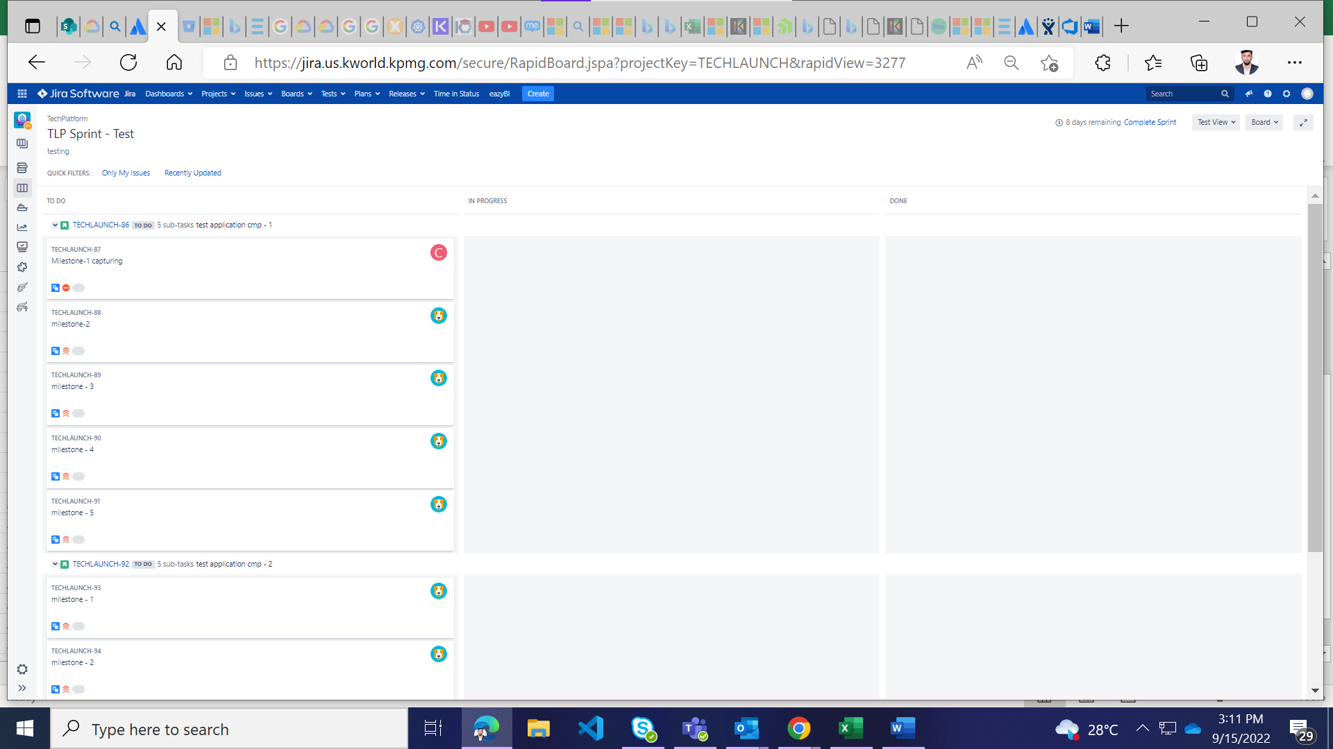

Here is an example of a user story having 5 tasks and named as milestones.

**Jira to CMP mapping:**

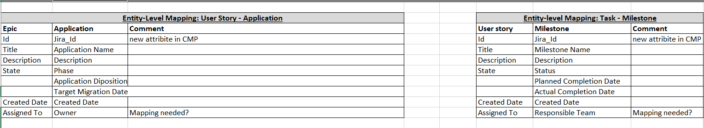

**Required Fields on the application (JIRA-US):**

**NOTE:**  Here we are targeting the **applications** table on the CMP

sd_hostname – **title**

Migration_rvalue - this can be **status** . (status should be modified as R-Values. **Admin** of the Jira application has elevated access to customize the names of status ) **OR** While Importing fix a R-value for the whole batch of import. Eg: If you are importing if from JIRA determine the R-value prior to import by setting up by **default** value.

wave - (we can use lables or customized fields from JIRA )

Target Cloud Provider - this can be **labels**

Owner - this can be **assignee** or **reportee**

Target_date - this can be **Due date**

Application_status - ( this is the status of whole applications generated based on all the milestones status under the application. Auto generated based on the below scenarios )

**Required Fields on the Milestone ( SUB-TASK):**

**NOTE:**  When importing sub-task we need to extract tminus-template data out of it too. So, here two tables are gonna be imported. One is **Tminus-schedule** table and **Tminus-template** table.

milestone – **title** of sub task ( tminus_template table)

Tminus_value - this can be **labels**.

Status – this can be **status** of the sub-task

Mig_data_id – this is the **id** of the **user story** which is going to be mapped

Tminus_temp_id – create a tminus-template row and map its id to this column

Target_completion_date – this can be the **due date**

Actual_completion_date – there is logic here when importing. [ check for the status and if its in completed state assign the **actual_completion_date** with due date i.e; **target_completion_date** else leave this field as empty.

Is_completed – this can be fetched from the **status** of the milestone i.e; sub-task

Responsible_team – this can be **Assignee.** We should have assignee’s in the form of **group** or **team** to assign it this field.

NOTE: This status is mandatory for the application to display the pie chart and progress table on the dashboard.

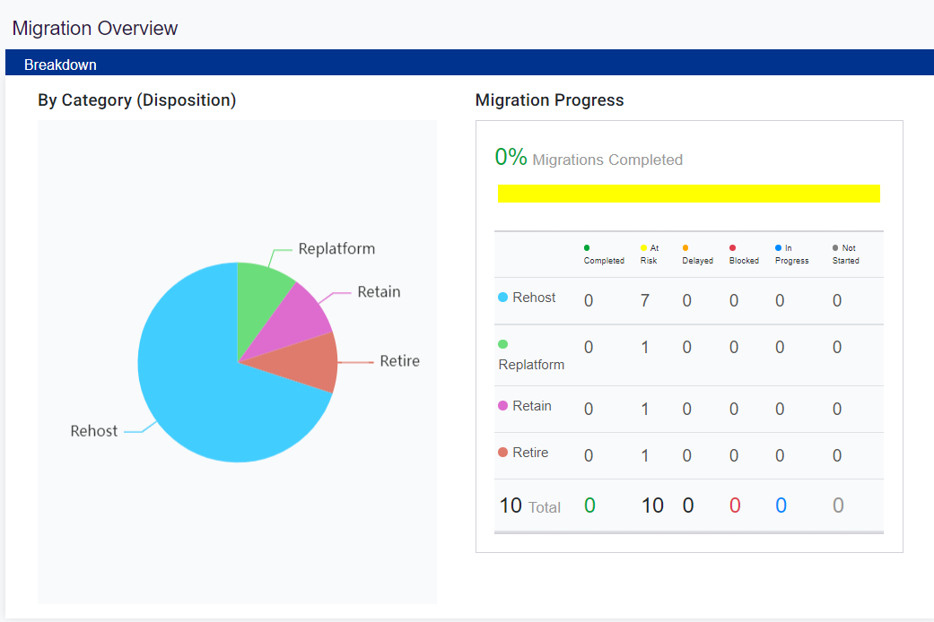

Application status scenario:

1. Completed - If all the milestones are in completed state.

2. Blocked – If any one of the milestones is in blocked state then the application is to be blocked.

3. At Risk – If target completion date of any milestone is due by over 2 weeks.

4. Delayed – if target completion date of any milestone is due and within 2 weeks of the completion date.

5. In-progress – If any one milestone under the application is in progress.

6. Not started – All the milestones should be in Not- Started state.

**Solution for status:**

An admin has privileges to add custom fields to the JIRA and also have permissions to add new values for the **status.** So, If we are using the status field as Migration R-Value, we can change those values to Rehost, Replatform, Retire, … etc. So, below URL explains how it is done and also an image of how the solution is captured is attached below.

[Add new status and steps to Jira server workflows | Jira | Atlassian Documentation](https://confluence.atlassian.com/jirakb/add-new-status-and-steps-to-jira-server-workflows-718835875.html#:~:text=Solution%201%20Log%20in%20as%20a%20user%20with,category%20for%20the%20status%20you%20want%20to%20add.)

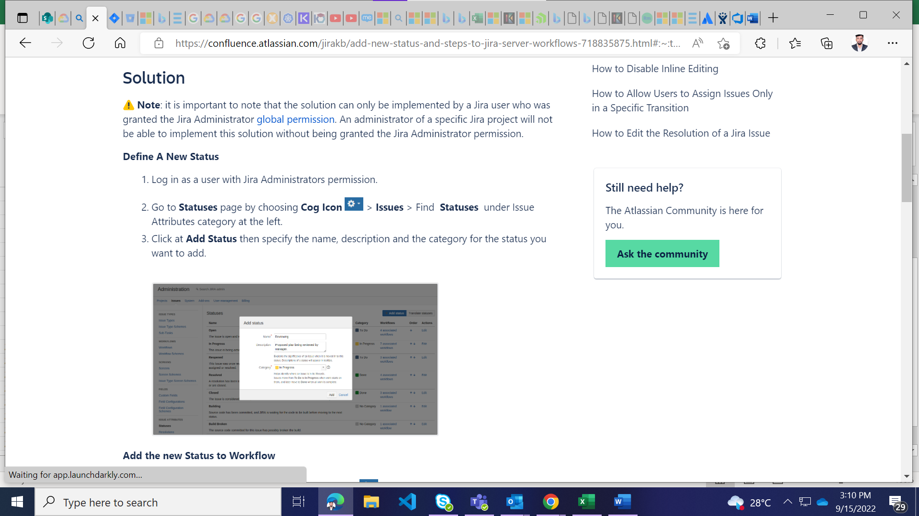

**JIRA to CMP database Mapping:**

**User Story Mapping:**

|  |  |  |
| --- | --- | --- |
| **Column name** | **JIRA User story fields** | **Datatype** |
| sd_hostname | title | varchar |
| migration_rvalue_id | status | Int ( fk ) -> public.rvalue |
| wave | customized jira field | varchar |
| target_csp | label | varchar |
| application_status_id |  | Int ( fk ) -> public.status |
| target_date | due date | date |
| ad_user_guid | assignee | varchar ( Azure User ID ) |

**Targeted Table -> public.migration_data**

**Sub Task Mapping:**

**Targeted Table -> public.tminus_template, public.tminus_schedule,public.user_group**

|  |  |  |
| --- | --- | --- |
| **Column name** | **JIRA Sub-Tasks fields** | **Datatype** |
| milestone | title | varchar ( **tminus_template** ) |
| t_minus_value | label | int ( **tminus_template** ) |
| migration_data_id | status | int ( fk ) public.migration_data |
| tminus_template_id | ID of the user story this task belongs to | int (fk) public.tminus_template |
| target_completion_date | due date | date |
| actual_completion_date | **assigned by logic** | date |
| is_completed | status – if completed | boolean |
| responsible_group_id | assignee (team working on task) | int(fk) public.responsible_group |